**Day 47**

**What to do?**

Do hyperparameter tuning of those projects with different kernel size, max pool layer etc.… Or apply these on new projects.

**Digits recognition:**

When hyperparameters were tuned, the best optimal values are

* number of filters used in ConvNets is 64
* pool size is 2
* number of units in the dense layer is 256
* learning rate for adam optimizer is 0.001

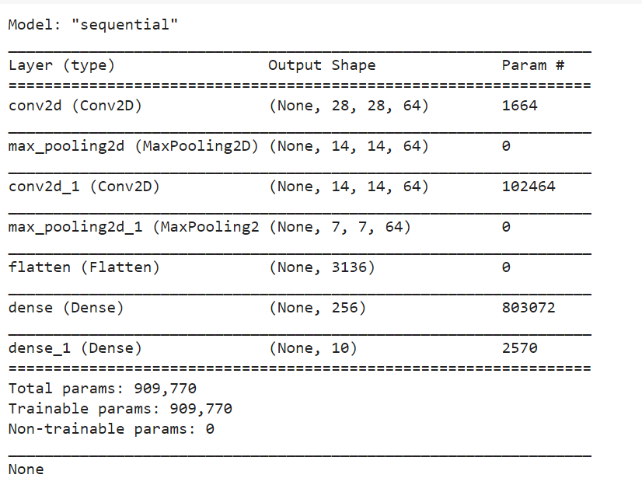

Results:

* Training accuracy: 99.23%
* Testing accuracy: 98.86%